**Factorial Analysis**

Given the prevalence of soft drink machines on campus a researcher was interesting in finding out if consumption of these drinks had an impact on learning. The research examined three variables related to the drinks: carbonation, caffeine, and sweetener. The researcher was interested in whether different combinations of these factors had an influence on memory tasks. The researcher varied carbonation (present, absent), amount of caffeine (none, moderate, heavy), and type of sweetener used (sugar, ½ sugar ½ artificial, artificial). The researcher gave a group of students a novel text to read and remember while consuming the drinks. Later these students were given a recall test and the number of recall errors was recorded.

* Run a between groups factorial analysis on these data and interpret the results of the analysis.

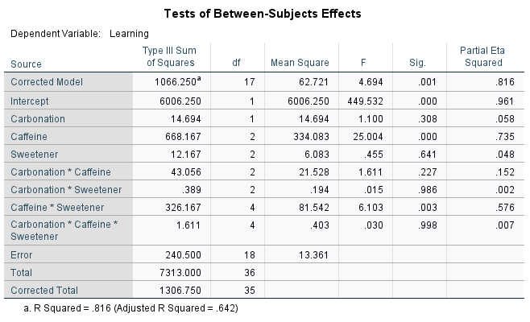

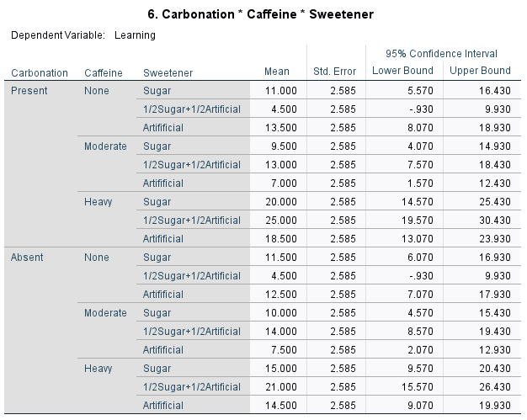

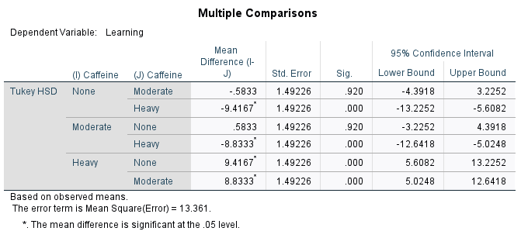

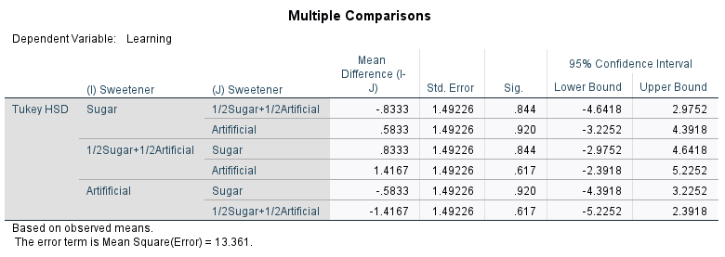

**Part 2: Question 1: Interpretation**

A factorial analysis was conducted to evaluate the impact of drinks carbonation, sweeteners and caffein on learning (recall). The means and standard deviations for the learning recall are presented in Table 2.1 below. The result of the analysis indicated a significant main effect for only caffeine, *F*(2,18) = 25.004, *p*(0.000) < 0.05, partial ɳ2 = 0.735, whereas, there were nonsignificant main effect for carbonation *p*(0.308) > 0.05 and sweetener *p*(0.641) > 0.05. In terms of interactions, there was significant interaction effect between caffeine and sweetener, *F*(4,18) = 6.103, *p*(0.003) < 0.05, partial ɳ2 = 0.576., but there were nonsignificant interaction effects between carbonation and caffeine, *p*(0.227) > 0.05, between carbonation and sweetener, *p*(0.986) > 0.05 and between carbonation caffeine and sweetener, *p*(0.998) > 0.05.

Table 2.1. Mean and Standard Deviation for Question 1

|  |  |  |  |  |
| --- | --- | --- | --- | --- |
| Carbonation | Caffeine | Sweetener | M | SD |
| Present | None | Sugar | 11.0000 | 1.41421 |
| 1/2Sugar+1/2Artificial | 4.5000 | 2.12132 |
| Artifificial | 13.5000 | 2.12132 |
| Moderate | Sugar | 9.5000 | 3.53553 |
| 1/2Sugar+1/2Artificial | 13.0000 | 4.24264 |
| Artifificial | 7.0000 | 1.41421 |
| Heavy | Sugar | 20.0000 | 1.41421 |
| 1/2Sugar+1/2Artificial | 25.0000 | 5.65685 |
| Artifificial | 18.5000 | 7.77817 |
| Absent | None | Sugar | 11.5000 | 2.12132 |
| 1/2Sugar+1/2Artificial | 4.5000 | .70711 |
| Artifificial | 12.5000 | 3.53553 |
| Moderate | Sugar | 10.0000 | 1.41421 |
| 1/2Sugar+1/2Artificial | 14.0000 | 2.82843 |
| Artifificial | 7.5000 | 3.53553 |
| Heavy | Sugar | 15.0000 | 2.82843 |
| 1/2Sugar+1/2Artificial | 21.0000 | 7.07107 |
| Artifificial | 14.5000 | 2.12132 |

* Run these data as a mixed factorial design with carbonation as the repeated (within) variable.

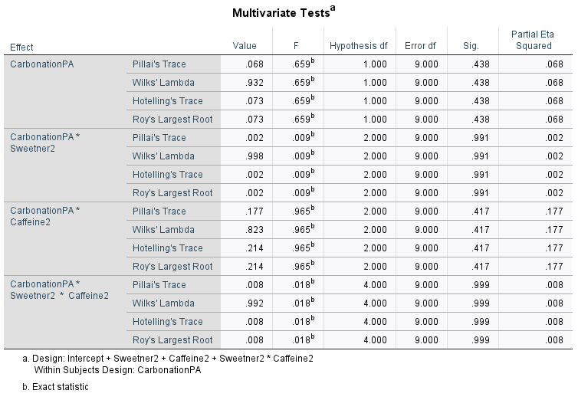

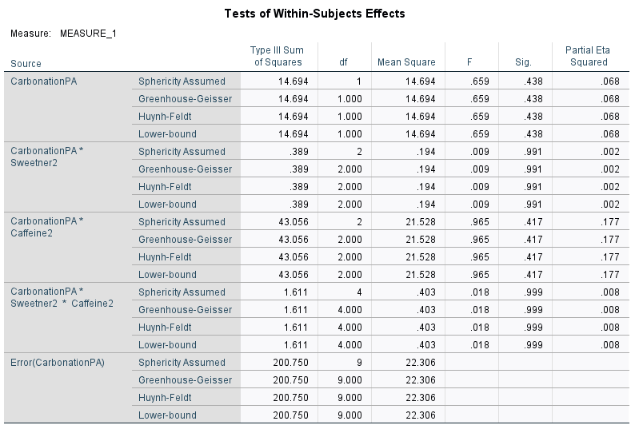

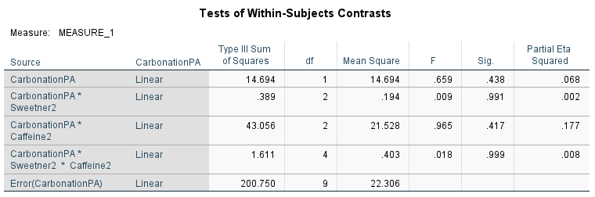

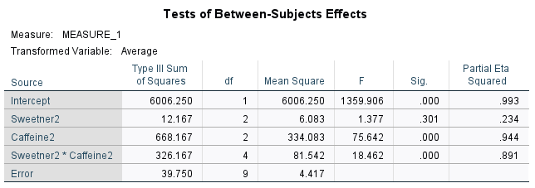

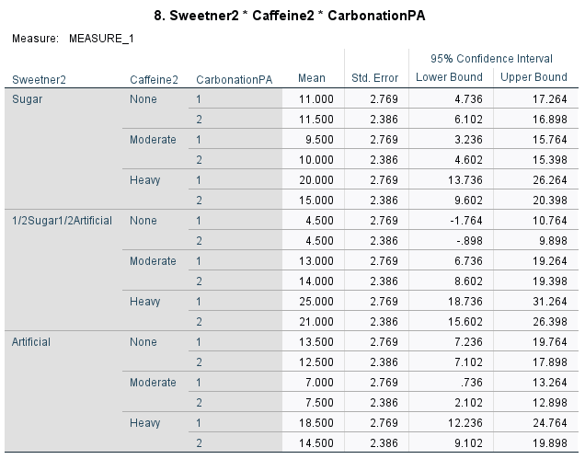

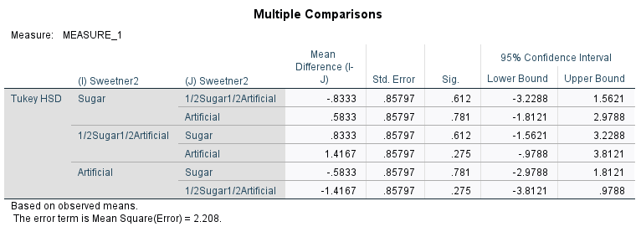

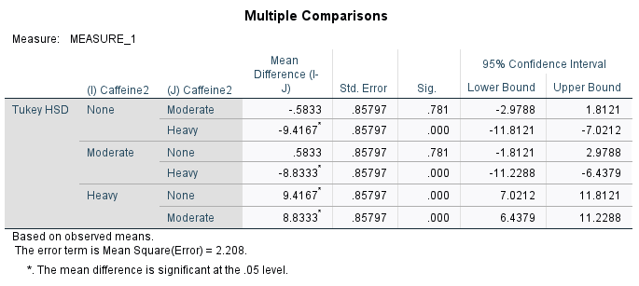

How does the analysis change?

The analysis changes because test of within subject effect was generated, test of within subject contrast was generated in addition to the test of between subject effects. However, in the test of between subject effect, only caffeine and interaction between caffeine and sweetener was significant as earlier reported.

Does your interpretation change?

No, my interpretation remains the same. Because there was no any level of significance form within subject effects that could change my earlier interpretations.